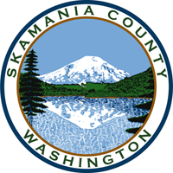
Skamania County
Noxious Weed Control Board

October Regular Meeting Agenda
Date: October 4, 2022

General Meeting
- Call to Order
- Approval of Agenda Items
- Approval of August Minutes

Public Comment

Financial Report
- Expenditures to date
- Revenue
- 2023 Budget

Staff Reports

Coordinator

Board Member Reports/Comments

Unfinished Business

New Business

Next meeting: January 3, 2023

Adjourn

