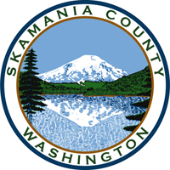
Skamania County
Noxious Weed Control Board

June Regular Meeting Agenda
Date: June 7, 2022

General Meeting
- Call to Order
- Approval of Agenda Items
- Approval of April Minutes

Public Comment

Financial Report
- Expenditures to date

Staff Reports

Coordinator

Board Member Reports/Comments

Unfinished Business
- Cost share program

New Business

Next meeting: August 2

Adjourn

