## 

## **Tansy Ragwort**

Senecio jacobaea

Sunflower Family

### **INTRODUCTION**

### **Identification Tips**

* 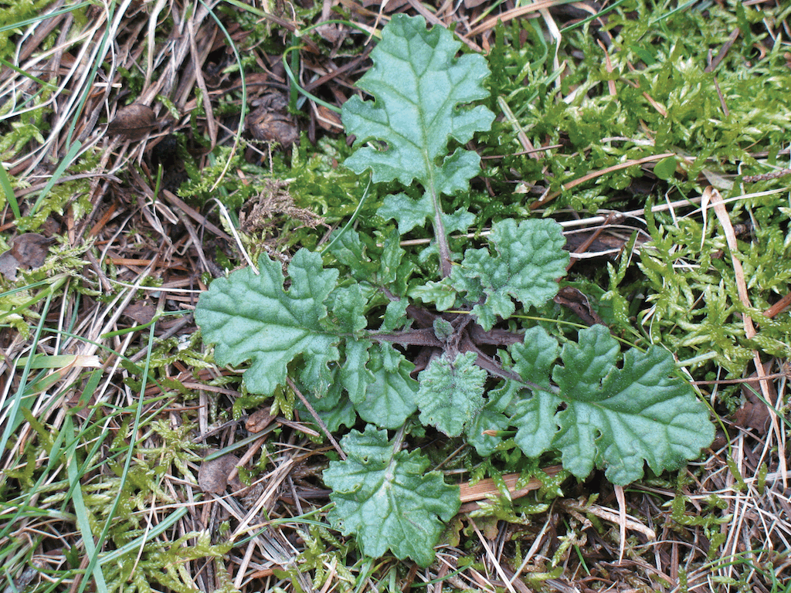Tansy ragwort is a biennial or short-lived perennial forb. It forms a rosette in its first year of growth before bolting the following year.
* After seed production, individual plants generally die; however, new rosettes can grow from the crown and root system.
* The rosette consists of dark green ruffled leaves.
* When bolting, the plants grow upright with stems 2-4 feet tall.
* The flowers are bright yellow with twelve daisy-like petals.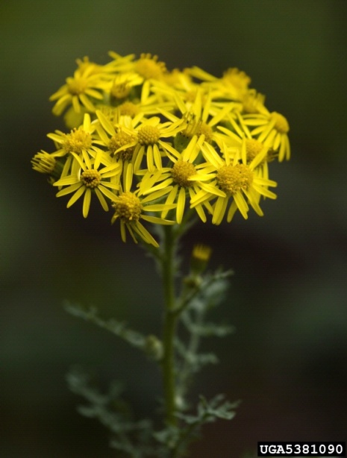

### **Impacts**

* Tansy ragwort is a serious threat to livestock. It contains pyrrolizidine alkaloids that are converted to toxic pyrroles in the liver after ingestion. The damage to the liver is cumulative and irreversible. Continued significant ingestion will usually kill the affected animal.
* All plant parts are toxic. When dried, tansy ragwort remains toxic but loses its bitter taste and can easily be consumed in hay or other food sources.

### **Habitat & Distribution**

* Tansy ragwort is often found in disturbed areas, open pastures, poorly managed grazing areas, and high traffic rights-of-way.
* It thrives in full or partial sun, on roadsides and horse trails, in forest clear-cuts and vacant lands.

### **Reproduction & Spread**

* Tansy ragwort reproduces by seed. A single plant is capable of producing up to 150,000 seeds, which can remain viable for up to 15 years. Seeds in the upper 2 cm of soil remain viable for 4 to 5 years.
* Plants can flower from June to October, but typically start to form seeds by mid-August.
* Seeds are spread in a variety of ways including wind, human traffic, in hay, on animals, and on equipment and vehicles.

# \\Scfs1\data\Weed\Photos\Tansy ragwort\tansy_ragwort_plant_wsnwcb.gif**CONTROL INFORMATION**

### **Integrated Pest Management**

* The preferred approach for weed control is Integrated Pest Management (IPM). IPM involves selecting from a range of possible control methods to match the management requirements of each specific site. The goal is to maximize effective control and to minimize negative environmental, economic, and recreational impacts.
* Use a multifaceted and adaptive approach. Select control methods reflecting the available time, funding, and labor of the participants, the land use goals, and the values of the community and landowners. Management will require dedication for a number of years and should allow flexibility in methods.

**Planning Considerations**

* Survey the area for weeds, set priorities, and select the best control method(s) for the site.
* Select control practices to minimize soil disturbance. Minimizing disturbance prevents further infestations of weeds.
* Begin work on the perimeter of the infested areas first and move inward toward the core of the infestation.
* Monitor the site and treat missed and newly-germinated plants.
* Re-vegetate treatment areas to improve ecological function and prevent new infestations.

### **Early Detection and Prevention**

* Minimize soil disturbance from vehicles, machinery, and over-grazing to reduce seed germination.
* Tansy ragwort is easily identified in both rosette and flower form. Plants begin blooming in mid-June. Evergreen rosettes can be identified year-round. Conduct a site survey to determine treatment needs.
* Hand pull or dig small or isolated infestations, making sure to get the entire root. Larger infestations may benefit from the proper use of an appropriate herbicide.
* Monitor for new plants and re-treat as necessary. Ensure any existing plants do not produce and release seed.
* Cut and bag seed heads to prevent seed spread.
* When moving animals from an infested area to an un-infested area, first isolate animals for at least 5 days to ensure that seeds pass through the animal’s digestive system.
* Thoroughly clean tools, boots, and vehicles after working in or traveling through an infested area.

### **Manual, Mechanical, & Cultural Control**

* Pull or dig tansy before it flowers, typically from May to June. Because this is a toxic plant, gloves should be worn.
* If plants are pulled after flowers have formed, carefully bag the flower heads, as seed can continue forming even after the plants have been uprooted.
* Once mature plants have been removed, survey the site for any rosettes and dig these up by the roots.
* Re-visit the site several times each season to remove any new plants that appear from the seed bank and continue to monitor for several years.
* Mowing is not effective in controlling tansy ragwort. Plants that are regularly mowed can persist as short-lived perennials or can flower below the level of the mower. It may also increase the amount of toxin ingested by livestock because grazing animals are unable to avoid eating small tansy ragwort plants growing among pasture grasses.
* Prevent soil disturbance and re-vegetate disturbed areas to prevent tansy ragwort infestations.
* Use proper grazing practices combined with seeding native species to develop healthy and weed-free land.

### **Biological Control**

Biological control is the deliberate introduction of insects, mammals, or other organisms which adversely affect the target weed species. Biological control is generally most effective when used in conjunction with other control techniques.

* The ragwort flea beetles (*Longitarsus jacobaeae*) mine the roots of the rosettes and kill plants in the spring when they start to bolt. Flea beetles are most effective in sunny pastures that do not flood and are below 2400 feet in elevation.
* Biological control can take up to six years to have a significant impact. Population density and the number of flowering plants can be reduced, but there will always be some plants remaining. Therefore, any biological control plan needs to incorporate another non-chemicalcontrol method to be able to prevent all seed production.
* Biological control is not recommended for small infestations.

### **Herbicide Control**

* Only apply herbicides at proper rates and for the site conditions or land usage specified on the label. **Follow all label directions** and wear recommended personal protective equipment (PPE).
* Some herbicides are toxic to fish and other aquatic invertebrates and/or may easily injure non-target species like crops growing nearby because of volatilization. **Always read and follow the label to avoid environmental and unintended damages.**
* Monitor treatment areas for missed and newly-germinated plants.
* Choose selective herbicides over non-selective herbicides when applying in a grassy area.
* **Minimize the impacts to bees and other pollinators by controlling weeds before they flower. When possible, make herbicide applications in the morning or evening when bees are least active. Avoid spraying pollinators directly.**

### **Specific Herbicide Information**

Herbicides are described here by the active ingredient. Many commercial formulations are available containing specific active ingredients. **References to product names are for example only.**Directions for use may vary between brands.

* Apply selective herbicides in the spring before any flowers appear. Fall applications after rains have initiated seed germination can also be effective. Check label for specific information on rain guidelines.
* Selective herbicides that are effective on tansy ragwort include 2,4-D, dicamba or a combination (*e.g.* Weedmaster, Weed-B-Gon). \***Please use care when using herbicides that may volatize to form a vapor that can drift during weather inversions or when the temperatures are above 80°F. These herbicides (*e.g.* 2,4-D, dicamba, etc.) may damage desirable nearby non-target plants or crops following an application. For more information, and to minimize risk, always read and follow the label.**
* Spot spraying with glyphosate (Roundup) can effectively control tansy ragwort. Treatment with glyphosate may need to be combined with effective re-vegetation of the site to prevent tansy ragwort seedlings from re-infesting the area.
* Re-treatment is necessary to control late-germinating plants. Monitor for new plants for at least four years after the initial treatment and following any disturbance to the soil such as tilling or construction.

This BMP does not constitute a formal recommendation. **When using herbicides, always consult the label.** Please refer to the [Pacific Northwest Weed Management Handbook](http://pnwhandbooks.org/weed/other-items/control-problem-weeds) or contact your [local](http://www.nwcb.wa.gov/nwcb_county.htm) weed authority.

**Resources**

<http://columbiagorgecwma.org/weed-listing/best-management-practices/tansy-ragwort/>

<http://hortsense.cahnrs.wsu.edu/Search/MainMenuWithFactSheet.aspx?CategoryId=6&ProblemId=2041>

<http://www.co.jefferson.wa.us/WeedBoard/pdfs/BestManagementPractices>

<http://www.kingcounty.gov/environment/animals-and-plants/noxious-weeds/weed-control-practices/bmp.aspx>

<http://www.nwcb.wa.gov>