## **Scotch Broom**

Cytisus scoparius (L.)

Pea Family

### **\\Scfs1\data\Weed\Photos\Scotch broom\scotchbroom6_nwcb.jpgINTRODUCTION**

### **Identification Tips**

* Scotch broom is a large, multi-branched, perennial shrub.
* Plants can grow up to 12 feet tall, with “old growth” Scotch broom trunks measuring as much as 5 inches in diameter.
* Young stems are bright green, with 5 sides and distinctive ridges along the entire length.
* Leaves are small and oval, and usually in clusters of 3 close to the stem but borne singly further out.
* 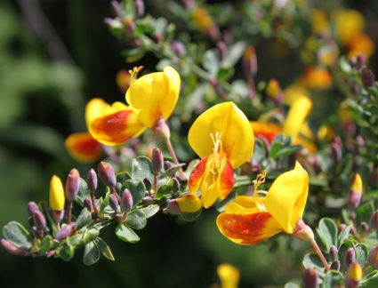Flowers are bright yellow, pea-like, and occasionally have streaks of red along the blossom.
* Seed pods are typically 1-3 inches long and range in color from green (when newly formed) to brown or black as they mature.

### **Impacts**

* Scotch broom is highly invasive on disturbed soils and can quickly out-compete native species. It is difficult to remove once established, especially because of its long-lived seed bank.
* 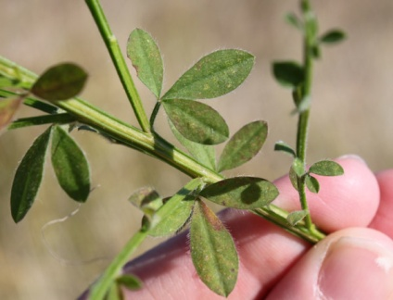Scotch broom is allelopathic, meaning it leaches chemicals into the soil that kills or disrupts the ectomycorrhizal fungal pathways on which other plants rely.
* The oils in Scotch broom are very flammable which can pose a fire hazard.
* Dense stands can impede the movement of wildlife, prevent timber regeneration, and displace pasture forage for grazing animals.
* It is also toxic to some livestock.

### **\\Scfs1\data\Weed\Photos\Scotch broom\5447450-Leslie J Mehrhoff_Univ of Conn_Bugwood.org.jpgHabitat & Distribution**

* Scotch broom grows best in full sun and well-drained soils. It is commonly found in clear-cuts or harvested timberlands, along roadsides and rights-of-way, and on land which has been disturbed.
* While Scotch broom thrives in full sun, seedlings can also establish in partial to full shade.

### **Reproduction & Spread**

* Scotch broom reproduces by seed. A single plant can produce up to 10,000 seeds per year.
* Seed pods reach maturity in late July and August, and pods begin exploding audibly, ejecting seeds up to 20 feet.
* Seeds can remain viable for more than 60 years because of their hard shells. This enables new seedlings to establish in areas where there appear to be no plants.
* Seeds are transported by animals, erosion, water, and human activity, especially road maintenance.

# **CONTROL INFORMATION**

### **Integrated Pest Management**

* The preferred approach for weed control is Integrated Pest Management (IPM). IPM involves selecting from a range of possible control methods to match the management requirements of each specific site. The goal is to maximize effective control and to minimize negative environmental, economic, and recreational impacts.
* Use a multifaceted and adaptive approach. Select control methods reflecting the available time, funding, and labor of the participants, the land use goals, and the values of the community and landowners. Management will require dedication for a number of years and should allow flexibility in methods.

**Planning Considerations**

* Survey the area for weeds, set priorities, and select the best control method(s) for the site.
* Select control practices that minimize soil disturbance. Minimizing disturbance prevents further infestations of weeds.
* Begin work on the perimeter of the infested areas first and move inward to the core of the infestation.
* Monitor the site and continue to treat missed and newly-germinated plants.
* Re-vegetate treatment areas to improve ecosystem function and prevent new infestations.

### **Early Detection and Prevention**

* Minimize soil disturbance from vehicles, machinery, and over-grazing to reduce seed germination.
* Scotch broom is easiest to identify in May, when flowers have formed. Conduct a site survey to determine treatment needs.
* Small infestations can be effectively managed by hand-pulling or digging plants out by the roots.
* Larger infestations may benefit from the proper use of an appropriate herbicide.
* Monitor and re-treat as necessary. Ensure any existing plants do not produce and release seed.
* Prevent the spread of Scotch broom by thoroughly cleaning tools, boots, and vehicles after working in or traveling through an infested area.

### **Manual, Mechanical, & Cultural Control**

* Manual control of Scotch broom can be used in combination with other control methods. Small Scotch broom plants can be dug or pulled out by the root before seed-heads begin forming. If the entire root cannot be removed, cut the plant below the crown of the root (usually just below soil level).
* Cutting can also be an effective method of controlling Scotch broom. Cut mature plants before seed pods begin developing to reduce spread. For larger trunks, a bow saw may be useful; otherwise, loppers can be used.
* Some digging and cutting can disturb soil and cause seed germination. Be sure to monitor the site closely for regrowth.
* Mechanical methods, including mowing, are not as effective in controlling Scotch broom. Combining mechanical methods with other methods can increase effectiveness. Plants should be mowed before seed pod maturation to prevent seed spread.
* Mowing is most effective when used on plants with diameters greater than 2 inches, as older plants are less likely to re-sprout from cut stems. Younger plants re-sprout aggressively.
* Mow in the spring and follow up with an autumn herbicide application for the most effective mechanical method.
* Lopping small infestations below the root crown can be effective.
* **Bulldozing is not recommended** as it disturbs the soil, spreads the seeds on site, encourages seed germination, and destroys other vegetation that would out-compete Scotch broom.
* Avoid soil disturbances and re-vegetate disturbed areas to prevent spreading Scotch broom infestations.

### **Biological Control**

Biological control is the deliberate introduction of insects, mammals, or other organisms which adversely affect the target weed species. Biological control is generally most effective when used in conjunction with other control techniques.

* Three biological control agents, a beetle (*Bruchidius villosus)*, a seed weevil (*Exapion fuscirostre)*, and a twig miner (*Leucoptera spartifoliella)*, are approved for release and have been established in Oregon and Washington. These agents will not control existing plants, but they can significantly reduce seed production. Contact your local weed authority for more information.
* Goats have been employed in the task of Scotch broom control and removal.

### **Herbicide Control**

* Only apply herbicides at proper rates and for the site conditions or land usage specified on the label. **Follow all label directions** and wear recommended personal protective equipment (PPE).
* Some herbicides are toxic to fish and other aquatic invertebrates and/or may easily injure non-target species like crops growing nearby because of volatilization. **Always read and follow the label to avoid environmental and unintended damages.**
* For control of large infestations, herbicide use may be effective either alone or in combination with mowing. Treated areas should not be mowed until after the herbicide has taken effect and weeds are brown and dead.
* Monitor treated areas for missed and newly germinated plants.
* Choose selective herbicides over non-selective herbicides when applying in a grassy area.
* **Minimize the impacts to bees and other pollinators by controlling weeds before they flower. When possible, make herbicide applications in the morning or evening when bees are least active. Avoid spraying pollinators directly.**

### **Specific Herbicide Information**

Herbicides are described here by the active ingredient. Many commercial formulations are available containing specific active ingredients. **References to product names are for example only.** Directions for use may vary between brands.

* A foliar application of triclopyr (Vastlan) is a very effective treatment for Scotch broom. Apply when Scotch broom is actively growing, preferably before flowering. Ensure full coverage of the plant to be effective. Fall treatments of Scotch broom are also effective.
* A combination of triclopyr and 2,4-D**\*** (*e.g.* Crossbow) is also effective.
* **\*Please use care when using herbicides that may volatize to form a vapor that can drift during weather inversions or when the temperatures are above 80°F. These herbicides (*e.g.* 2,4-D, dicamba, etc.) may damage desirable nearby non-target plants or crops following an application. For more information, and to minimize risk, always read and follow the label.**
* Glyphosate (Round-Up) can effectively control Scotch broom when applied to actively growing plants in spring. Glyphosate is non-selective and will kill non-target vegetation such as grass. Treatments with glyphosate should be combined with effective revegetation in treated areas.
* Addition of a surfactant to spray mixes will improve results. Foliage must be thoroughly wetted, although not to the point of runoff. Re-treatment will be necessary to control late-germinating plants.
* Triclopyr and glyphosate can both be used as a cut-stump application. Herbicide is diluted to 50% solution and applied to stumps immediately following cutting.

This BMP does not constitute a formal recommendation. **When using herbicides, always consult the label.** Please refer to the [Pacific Northwest Weed Management Handbook](http://pnwhandbooks.org/weed/other-items/control-problem-weeds) or contact your [local](http://www.nwcb.wa.gov/nwcb_county.htm) weed authority.

**Resources**

<http://columbiagorgecwma.org/weed-listing/best-management-practices/scotch-broom/>

<http://hortsense.cahnrs.wsu.edu/Home/HortsenseHome.aspx>

<http://www.co.jefferson.wa.us/WeedBoard/pdfs/BestManagementPractices/Scotch%20Broom.pdf>

<http://www.kingcounty.gov/environment/animals-and-plants/noxious-weeds/weed-control-practices/bmp.aspx>

<http://www.nwcb.wa.gov>

