## 

## **poison hemlock**

Conium maculatum

Parsley Family

### **INTRODUCTION**

### **Identification Tips**

### Poison hemlock is an herbaceous biennial with a fleshy, white taproot. This member of the parsley family can grow up to 10 feet tall.

* Fern-like, glossy-green leaves are finely divided into leaflets and grow on a smooth, hollow stem with purple blotches. Crushed foliage has a musty odor.
* Small, 5-petaled, white flowers grow on stalks in 4-inch, umbrella-shaped clusters and bloom from April to July.
* 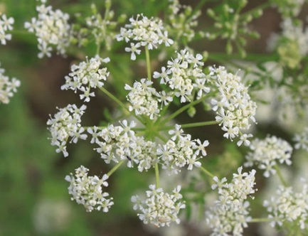Paired seeds form in ridged capsules.
* It can be confused with other plants in the carrot family, but its height as well as the hairless, purple-blotched stem are key identifying traits for poison hemlock.

### **Impacts**

* All parts of poison hemlock are highly toxic, including seed heads. It retains toxicity in hay because **dead stems remain toxic for up to three years.**
* 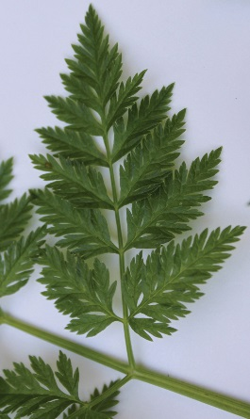The acute toxicity of poison hemlock to humans, livestock, and wildlife is fatal.
* Contact dermatitis can occur if handled without gloves and long-term inhalation of the toxic vapors is poisonous.
* Poison hemlock is aggressive and easily colonizes pastures, roadsides, riparian corridors, and other disturbed areas.

### **Habitat & Distribution**

* Poison hemlock can grow in a variety of settings, including dry or moist sites and poorly-drained soils.
* Native to Europe, Asia, and North Africa, poison hemlock is common throughout the Pacific Northwest.

### **Reproduction & Spread**

* Poison hemlock is a prolific seed producer and reproduces only by seed.
* Seeds are spread by animals, water, vehicles, or other human activities that disturb the soil.
* Seeds can remain viable in the soil for 2 to 3 years.

# **CONTROL INFORMATION**

### **Integrated Pest Management**

* The recommended approach for weed control is Integrated Pest Management (IPM). IPM involves selecting from a broad range of control methods to strengthen the impact of management practices given the ecology of the pest and the specific site conditions where it occurs. The goal of IPM is to maximize effective control and to minimize negative environmental, economic, and recreational impacts.
* Use a multifaceted and adaptive approach. Select control methods reflecting the available time, funding, and labor of the participants, the land use goals, and the values of the community and landowners. Management will require dedication for a number of years and should allow flexibility in methods.

**Planning Considerations**

* Survey area for weeds, set priorities, and select the best control method(s) for the site.
* Control practices should be selected to minimize soil disturbance. Minimizing disturbance prevents further infestations of weeds.
* Begin work on the perimeter of the infested area first and move inward toward the core of the infestation.
* Monitor the site and continue to treat plants that germinate from the seed bank.
* Revegetate the treatment areas to improve ecosystem function and prevent new infestations.

### **Early Detection and Prevention**

* Poison hemlock can be identified most of the year.
* Control new infestations as early as possible, in the fall when rosettes have emerged or in early spring.
* Minimize soil disturbance from vehicles, machinery, and over-grazing to reduce seed germination.
* Monitor for new plants and re-treat as necessary. Ensure any existing plants do not produce and release seed.
* Prevent the additional spread of invasive species by thoroughly cleaning tools, boots, and vehicles after working in or traveling through an infested area.

### **Manual, Mechanical, & Cultural Control**

* **Note: Protective clothing, including gloves, should be worn when handling poison hemlock. Consider wearing a dusk mask when mowing or tilling to prevent inhalation of toxins.**
* For small infestations, when plants are young, digging can be effective if the entire taproot is removed. Dispose of plant material in the garbage, not the compost, to prevent accidental poisoning.
* Repeated plowing of newly germinated plants can control seedlings and prevent seed formation. This may need to be done more than once a year.
* When plants have bolted, but before flowering, repeated mowing throughout the season can reduce seed production. Eventually, routine mowing can deplete poison hemlock’s energy reserves and decrease its ability to compete with surrounding vegetation. Monitor the area frequently for re-sprouting.

### **Biological Control**

Non-native plants easily establish large infestations and become widespread in their introduced range because they have no natural enemies as they do in their native range. Biological control deliberately reunites a species with its natural enemies, including insects and pathogens, in hopes of achieving the balance found in the plant’s native range. Biological control is not available for all species and will only reduce seed production or the size of the infestation, not eradicate it. It is generally most effective when used in conjunction with other control techniques.

* The larvae of the European palearctic moth *Agonopterix alstroemeriana* feed on the foliage, buds, and flowers of poison hemlock in spring and early summer.
* Although the introduction was likely an accident, the moth is widespread and is not currently being distributed by biocontrol project leaders.
* While the only known host plant to the moth is poison hemlock, it has not proven to be effective at controlling most infestations.

### **Herbicide Control**

* Only apply herbicides at proper rates and for the site conditions or land usage specified on the label. **Follow all label directions** and wear recommended personal protective equipment (PPE).
* For control of large infestations, herbicide use may be effective either alone or in combination with mowing. Mowing prior to treatment (and flowering) and then spraying re-growth can reduce the amount of herbicide needed. Treated areas should not be mowed until after the herbicide has taken effect and weeds are brown and dead.
* Monitor treated areas for missed and newly germinated plants. Selective herbicides are preferred over non-selective herbicides when applying in a grassy area.
* Some herbicides are toxic to fish and other aquatic invertebrates and/or may easily injure non-target species like crops growing nearby because of volatilization. **Always read and follow the label to avoid environmental and unintended damages.**
* **Minimize impacts to bees and other pollinators by controlling weeds before they flower. If possible, make herbicide applications in the morning or evening when bees are least active. Avoid spraying pollinators directly.**

### **Specific Herbicide Information**

Herbicides are described here by the active ingredient. Many commercial formulations are available containing specific active ingredients***.* References to product names are for example only.** Directions for use may vary between brands.

Control poison hemlock effectively with a foliar application to rosettes or bolted (pre-flower) plants with any of the following herbicides available to both residential users and small, non-commercial operations:

* Triclopyr (Ortho Max Poison Ivy and Tough Brush Killer): most effective when applied from seedling to rosette stage
* 2,4-D**\*** (Agri star): most effective when applied soon after plants reach rosette stage
* Glyphosate (Round-Up): apply to actively growing plants before bolting
* For large infestations, a combination of mowing and then treating the regrowth may be the best option. Follow-up as necessary.
* Continuously monitor for new plants, especially following any disturbance to the soil such as tilling or construction, until the seed bank has been depleted.
* **\*Please use care when using herbicides that may volatize to form a vapor that can drift during weather inversions or when the temperatures are above 80°F. These herbicides (*e.g.* 2,4-D, dicamba, etc.) may damage desirable nearby non-target plants or crops following an application. For more information, and to minimize risk, always read and follow the label.**

**Contractors/Licensed Applicators**

* Metsulfuron (Escort) + a nonionic surfactant or silicone surfactant is effective in spring when plants are actively growing. See PNW Handbook for more detail.

This BMP does not constitute a formal recommendation. **When using herbicides, always consult the label.** Please refer to the [Pacific Northwest Weed Management Handbook](http://pnwhandbooks.org/weed/other-items/control-problem-weeds) or contact your [local](http://www.nwcb.wa.gov/nwcb_county.htm) weed authority.

**Resources**

<http://columbiagorgecwma.org/weed-listing/best-management-practices/poisonhemlock/>

<http://hortsense.cahnrs.wsu.edu/Home/HortsenseHome.aspx>

<http://ipm.ucanr.edu/PMG/PESTNOTES/pn74162.html>

<https://pnwhandbooks.org/weed/problem-weeds/hemlock-poison-conium-maculatum>

<http://www.nwcb.wa.gov>

<https://www.nwcb.wa.gov/images/weeds/Poison-Hemlock_factsheet_King.pdf>