## 

## **Knotweeds**

**Bohemian knotweed(*Fallopia* x *bohemica*)**

**Japanese knotweed(*Fallopia japonica*)**

**Giant knotweed(*Fallopia sachalinensis*)**

**Himalayan knotweed (*Persicaria wallichii*)**

Buckwheat Family

### **INTRODUCTION**

### **\\Scfs1\data\Weed\Photos\Knotweed\Photos\leafcomparison.JPGIdentification Tips**

* In the Pacific Northwest, there are four similar species of invasive knotweed that are difficult to tell apart and share similar habitats, impacts, and control methods. They are all large, robust perennials that spread by long creeping rhizomes to form dense thickets.
* Knotweeds are herbaceous perennial plants that can grow up to fourteen feet tall.
* 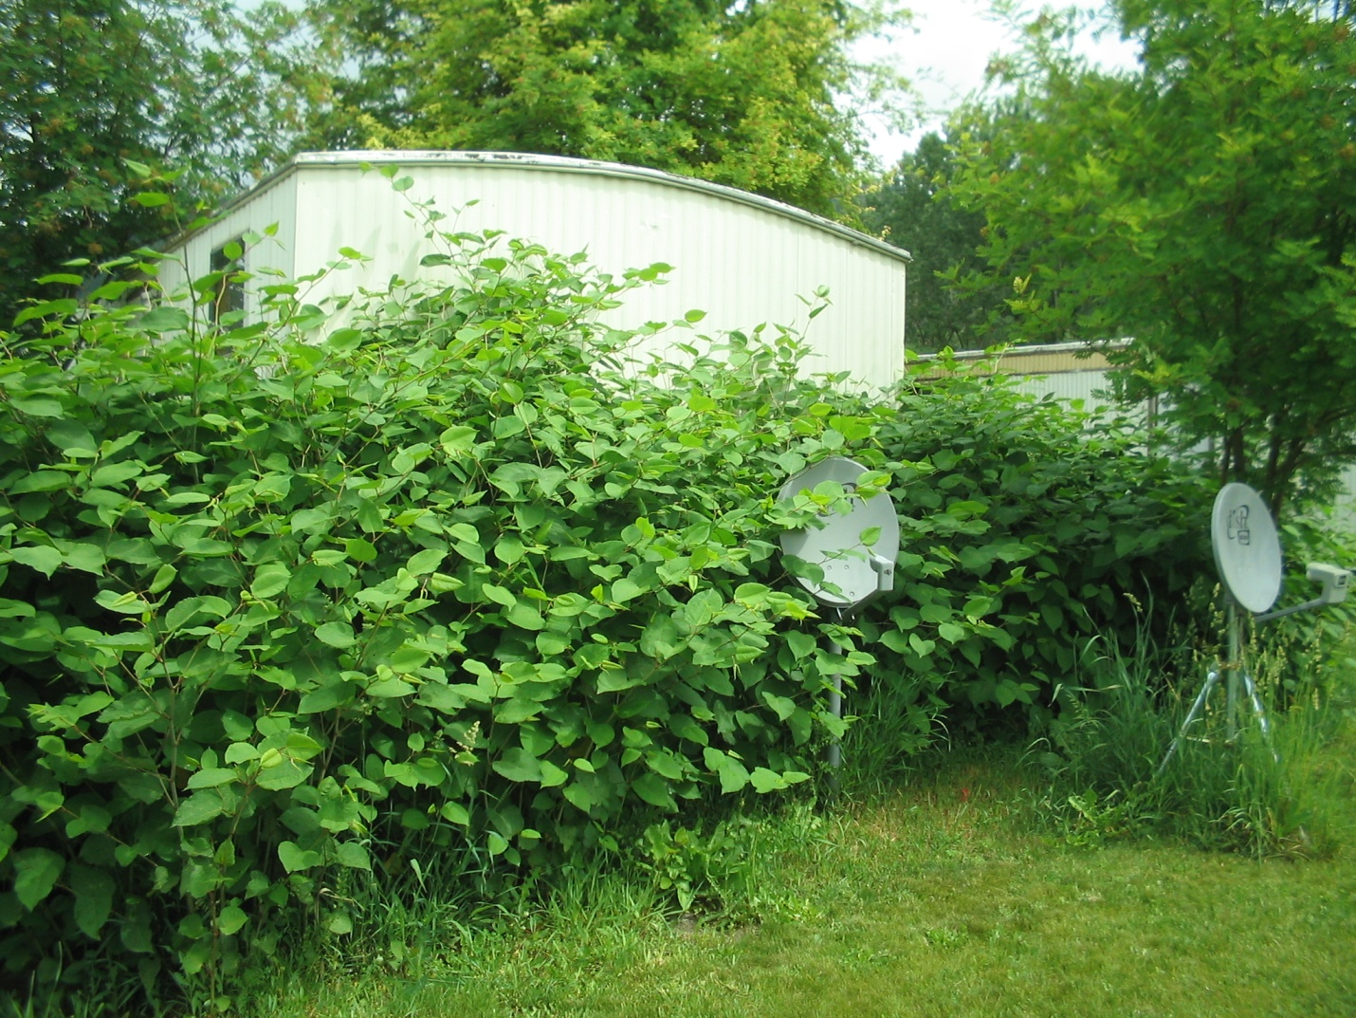The leaves are alternate and typically triangular or heart shaped.
* Stems are slender and red when young; as the plants mature, stems turn green and take on an appearance similar to bamboo, with jointed segments.
* Knotweed produces clusters of white flowers near the terminal end of the stems.

### **Impacts**

* Knotweed can completely clog small waterways and displace streamside vegetation, increasing bank erosion and lowering the quality of riparian habitat for fish and wildlife.
* Rapid spring growth and deep, extensive roots enable knotweed to outcompete most other plants, even small trees and shrubs.

### **Habitat & Distribution**

* Knotweed prefers riparian areas but can be found anywhere. Fill dirt is a common vector for this noxious weed. It can be found along roadsides, stream banks, and natural areas. Originally sold as an ornamental, it is also found in gardens, yards, vacant lots, field edges, parks, and other residential sites.
* Knotweeds can tolerate partial shade and are most competitive in moist, rich soil.

### \\Scfs1\data\Weed\Photos\Knotweed\Photos\P9240006.JPG**Reproduction & Spread**

* Reproduces by rhizomes, roots, stem pieces, and by seed. Stem fragments as small as ½ inch can sprout and form new canes.
* Knotweed most commonly spreads by water (stem fragments move downstream) or in contaminated soil.
* Seeds can remain viable in the soil for up to fifteen years.

# **CONTROL INFORMATION**

### **Integrated Pest Management**

* The preferred approach for weed control is Integrated Pest Management (IPM). IPM involves selecting from a range of possible control methods to match the management requirements of each specific site. The goal is to maximize effective control and to minimize negative environmental, economic, and recreational impacts.
* Use a multifaceted and adaptive approach. Select control methods reflecting the available time, funding, and labor of the participants, the land use goals, and the values of the community and landowners. Management will require dedication for a number of years and should allow flexibility in methods.

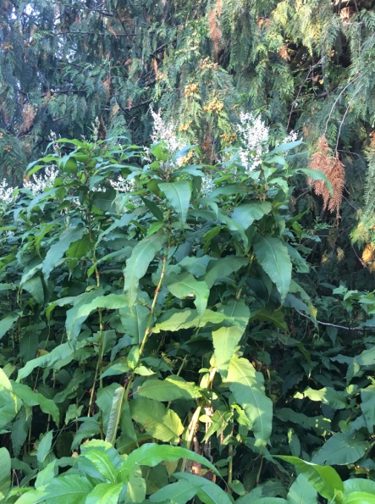**Planning Considerations**

* Survey the area for weeds, set priorities, and select the best control method(s) for the site. Because of knotweed’s incredibly extensive root system and sprouting ability, landscape level control requires long-term planning and follow-up. Plan to monitor the site and follow up with regular treatments for many years after the initial treatment.
* This plant spreads easily downstream by water, so it is necessary to begin control from the furthest upstream infestation, including all tributaries and other upstream sources of possible re-infestation.
* Although there are potentially successful mechanical or manual control options for very small patches, landscape level projects and large sites will require integrating herbicides into the control strategy.
* Select control practices to minimize soil disturbance or take efforts to mitigate or reduce the impacts of disturbance. Disturbed areas need to be stabilized to control erosion and sediment deposition. Minimizing disturbance also avoids creating more opportunities for germination of other weeds.
* Re-vegetate treatment areas to improve ecosystem function and prevent new infestations.

### **Early Detection and Prevention**

* Knotweed is easy to identify year-round. In the winter, look for clusters of tall, reddish stems with the distinct bamboo-like segmentation. Conduct a site survey to determine treatment needs. Monitor for new populations in May and June.
* When controlling knotweed, be careful working near water or digging in knotweed-infested soil. It spreads easily from root and stem fragmentation.
* Herbicide treatment is recommended. Monitor and re-treat as necessary.
* Do not discard stems or root fragments in waterways or on moist soil.
* **Never dump yard debris in natural areas.**

### **Manual, Mechanical, & Cultural Control**

* Light deprivation has proven effective in some cases. Geotextile can be laid over treatment areas well past the edge of the infestation. Periodic maintenance and “stomping” is required.
* Mechanical control of knotweed is not advisable due to the risk of inadvertently spreading it from cut fragments or soil/equipment contamination. Any cut plants should be dried completely to prevent regrowth prior to disposal.
* **Mowing is not an effective control method.**

### **Biological Control**

Biological control is the deliberate introduction of insects, mammals, or other organisms which adversely affect the target weed species. Biological control is most effective when used in conjunction with other control techniques.

* Goats are reported to eat knotweed and, in some circumstances, controlled goat grazing may be an option. Be aware that goats will eat desirable vegetation as well as knotweed.

### **Herbicide Control**

* Only apply herbicides at proper rates and for the site conditions or land usage specified on the label. **Follow all label directions** and wear recommended personal protective equipment (PPE).
* Monitor treatment areas for missed or new plants. The sturdy root system of knotweed resists herbicide treatments, so the infestation will need to be treated for many years.
* Selective herbicides are preferred over non-selective herbicides when applying in a grassy area.
* **Minimize impacts to bees and other pollinators by controlling weeds before they flower. If possible, make chemical applications in the morning or evening when bees are less active. Avoid spraying pollinators directly.**

### **Specific Herbicide Information**

Herbicides are described here by the active ingredient. Many commercial formulations are available containing specific active ingredients. **References to product names are for example only.** Directions for use may vary between brands.

* Use a foliar application of glyphosate (Roundup) during the growing season until first hard frost. Avoid spraying when flowering to reduce impacts to pollinators.
* If applying near water, herbicides and surfactants must be approved for use in aquatic sites. Some glyphosates (*e.g.* Rodeo, Aquamaster) are approved for aquatic use.
* Regardless of herbicide choice, large established patches will require many treatments over several years. Although infestations will be greatly reduced in the first years, maintenance on the smaller plants that will likely appear following treatment is necessary to control knotweed. It is important to search for shoots up to 10 yards from the central patch after herbicide treatment begins.

### **Contractors/Licensed Applicators**

* Use a foliar application during the growing season until first hard frost. Avoid spraying during flowering to minimize impacts to pollinators.
* Use an aquatic labeled surfactant and 1% imazapyr.
* For larger infestations, use surfactant plus 1% imazapyr + 2% glyphosate.

**If you think you may have knotweed, please contact your local county noxious weed authority for assistance.**

This BMP does not constitute a formal recommendation. **When using herbicides, always consult the label.** Please refer to the [Pacific Northwest Weed Management Handbook](http://pnwhandbooks.org/weed/other-items/control-problem-weeds) or contact your [local](http://www.nwcb.wa.gov/nwcb_county.htm) weed authority.

**Resources**

<http://columbiagorgecwma.org/weed-listing/best-management-practices/knotweeds/>

<http://dnr.wi.gov/topic/invasives/documents/japanese_knotweed_control.pdf>

<https://efotg.sc.egov.usda.gov/references/public/mn/797japaneseknotweed.pdf>

<http://www.invasive.org/gist/moredocs/polspp01.pdf>

<http://www.co.jefferson.wa.us/WeedBoard/pdfs/BestManagementPractices>

<http://www.kingcounty.gov/environment/animals-and-plants/noxious-weeds/weed-control-practices/bmp.aspx>

<http://www.nwcb.wa.gov>