## 

## **houndstongue**

Cynoglossum officinale

Borage Family

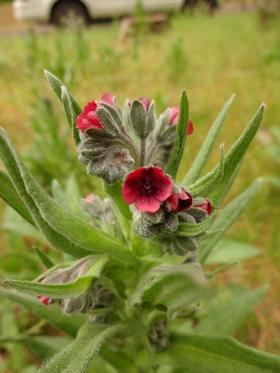

### **INTRODUCTION**

### **Identification Tips**

### Houndstongue is a biennial or short-lived perennial forb, growing from 1-4 feet tall.

* 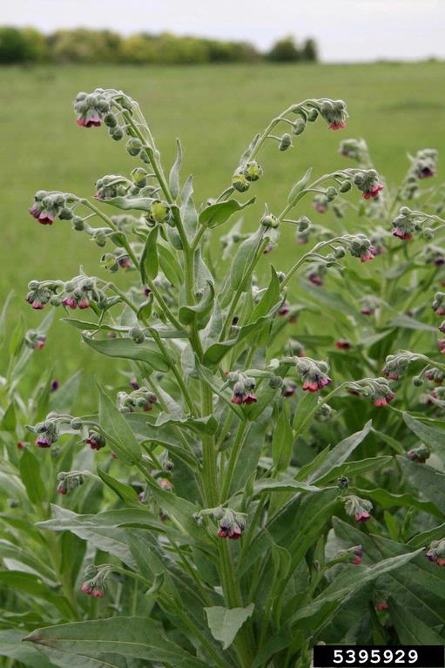Alternate leaves are well-veined with dense, soft whitish hairs on both sides and lack teeth or lobes. Upper leaves attach directly to the hairy stem.
* Small, 5-petaled flowers bloom from May – July. They range in color from dull red to burgundy and occur in clusters in upper leaf axils and at stem ends.
* Flowers form 3-4 flat, teardrop-shaped nutlets between July and August, with each nutlet containing one seed. Nutlets, with raised margins and many small prickles, are about ¼ inch long.
* The native houndstongue (*Cynoglossum grande*) typically has a single, hairless stem and leaves that are smooth on top and hairy below. Flowers, blooming from March to April, are blue and have 5 conspicuous white raised nubs in a central ring.

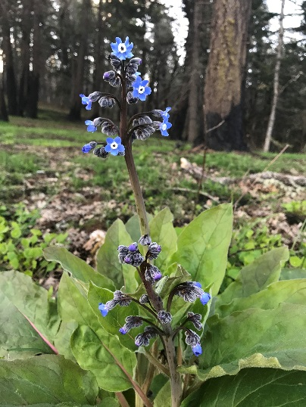

### **Impacts**

* The hair on the plants can cause skin irritation, therefore gloves should be worn when handling.
* Houndstongue carries an alkaloid poison that can kill livestock through reduced liver cell production. Usually the fresh plant is considered unpalatable and is avoided, but livestock may eat toxic plants when they are cut and dried with harvested hay.

*C. grande (native)*

### **Habitat & Distribution**

* Favoring disturbed areas, houndstongue can grow in a variety of conditions, from moist to dry sites, and is shade tolerant.
* Currently, houndstongue occurs only on the east side of the Cascade Mountain Range.

### **Reproduction & Spread**

* The fruit surface is covered with Velcro-like barbed hooks that become easily entangled in the wool or hair of animals, as well as on clothing and shoes.
* 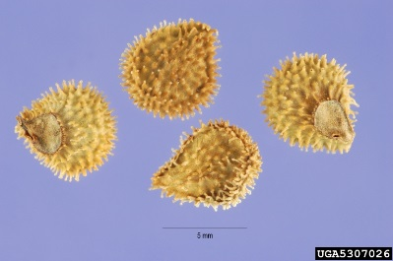Seeds are easily transported by animals, people, and vehicles and it can rapidly become an issue in forests and wet meadows.

# **CONTROL INFORMATION**

### **Integrated Pest Management**

* The recommended approach for weed control is Integrated Pest Management (IPM). IPM involves selecting from a broad range of control methods to strengthen the impact of management practices given the ecology of the pest and the specific site conditions where it occurs. The goal of IPM is to maximize effective control and to minimize negative environmental, economic, and recreational impacts.
* Use a multifaceted and adaptive approach. Select control methods reflecting the available time, funding, and labor of the participants, the land use goals, and the values of the community and landowners. Management will require dedication for a number of years and should allow flexibility in methods.

**Planning Considerations**

* Survey area for weeds, set priorities, and select the best control method(s) for the site.
* Control practices should be selected to minimize soil disturbance. Minimizing disturbance prevents further infestations of weeds.
* Begin work on the perimeter of the infested area first and move inward toward the core of the infestation.
* Monitor the site and continue to treat plants that germinate from the seed bank.
* Revegetate the treatment areas to improve ecosystem function and prevent new infestations.

### **Early Detection and Prevention**

* Control new infestations as early as possible.
* Minimize soil disturbance from vehicles, machinery, and over-grazing to reduce seed germination.
* Monitor for new plants and re-treat as necessary. Ensure any existing plants do not produce and release seed.
* Prevent the additional spread of houndstongue by thoroughly cleaning your pet’s hair, tools, boots, and vehicles after working in or traveling through an infested area.

### **Manual, Mechanical, & Cultural Control**

* When plants are young, hand pull the stem close to the ground or use a shovel to loosen the taproot. If plants are flowering or setting seed, bag plants and dispose of them in the garbage. Rosettes can also be pulled or dug in the fall.
* Mowing is an ineffective control measure for houndstongue and is not recommended.
* Avoid overgrazing in pastures to increase competition of grasses and forbs.

**Disposal Methods**

* Bag all flower heads. If the plants are in seed, carefully cut off the seed head and place in a bag without dispersing the seeds.
* Dispose of flower heads and plants in household garbage or take to a transfer station for disposal. Do not compost or put in yard waste.
* Never dump yard debris in natural areas.

### **Herbicide Control**

* Only apply herbicides at proper rates and for the site conditions or land usage specified on the label. **Follow all label directions** and wear recommended personal protective equipment (PPE).
* Some herbicides are toxic to fish and other aquatic invertebrates and/or may easily injure non-target species like crops growing nearby because of volatilization. **Always read and follow the label to avoid environmental and unintended damages.**
* Treated areas should not be mowed until after the herbicide has taken effect and weeds are brown and dead.
* Monitor treated areas for missed and newly germinated plants. Selective herbicides are preferred over non-selective herbicides when applying in a grassy area.
* **Minimize impacts to bees and other pollinators by controlling weeds before they flower. If possible, make herbicide applications in the morning or evening when bees are least active. Avoid spraying pollinators directly.**

### **Specific Herbicide Information**

Herbicides are described here by the active ingredient. Many commercial formulations are available containing specific active ingredients***.* References to product names are for example only.** Directions for use may vary between brands. Please read and follow the label.

Apply herbicides during the pre-bud stage (spring to early summer) or in the rosette stage (late summer to fall).

* 2,4-D + Dicamba* (*e.g.* Weedmaster) at a rate of 2 quarts/acre.
* \***Please use care when using herbicides that may volatize to form a vapor that can drift during weather inversions or when the temperatures are above 80°F. These herbicides (*e.g.* 2,4-D, dicamba, etc.) may damage desirable nearby non-target plants or crops following an application. For more information, and to minimize risk, always read and follow the label.**
* Continuously monitor for new plants, especially following any disturbance to the soil such as tilling or construction.

**Contractors/Licensed Applicators**

* Apply 1 pint/acre of Picloram (*e.g.* Tordon) + 1 quart/acre of 2,4-D and a non-ionic surfactant (*e.g.* Alligare 7, LI 700, or Dyne-Amic) to pre-bud or rosettes. Caution: picloram is a restricted use herbicide and cannot be used in all places. Take caution around conifers when using picloram.

This BMP does not constitute a formal recommendation. **When using herbicides, always consult the label.** Please refer to the [Pacific Northwest Weed Management Handbook](http://pnwhandbooks.org/weed/other-items/control-problem-weeds) or contact your [local](http://www.nwcb.wa.gov/nwcb_county.htm) weed authority.

**Additional Resources**

<http://columbiagorgecwma.org/weed-listing/best-management-practices/houndstongue/>

<http://hortsense.cahnrs.wsu.edu/Home/HortsenseHome.aspx>

<https://pnwhandbooks.org/weed/problem-weeds/houndstongue-cynoglossum-officinale>

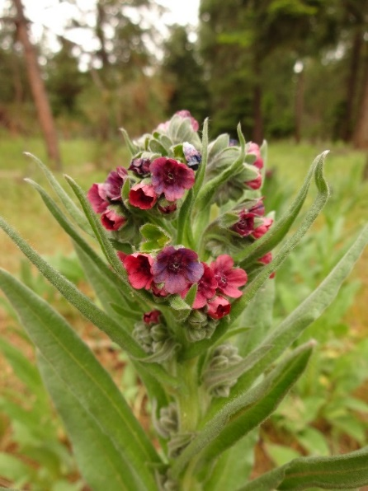<https://www.co.lincoln.wa.us/weedboard/wp-content/uploads/sites/4/2016/04/houndstongue.pdf>

<http://www.nwcb.wa.gov>

<https://www.pnwflowers.com/flower/cynoglossum-grande>