## 

## **Garlic Mustard**

Alliaria petiolata

Mustard Family

### **INTRODUCTION**

### **\\Scfs1\data\Weed\CWMA\CGCWMA\Farm Bill\FY16 Suggestion\EDRR Book\InDesign\2017 EDRR book_2nd edition\Linked Graphics\ALPE4_rosettes_es.tif**

### **Identification Tips**

* Garlic mustard is a tap-rooted biennial plant in the mustard family. The tap-root typically grows in an S-shape at the base of the plant.
* The leaves have a mild garlic odor when crushed, especially when young. Older plants can lack the odor.
* 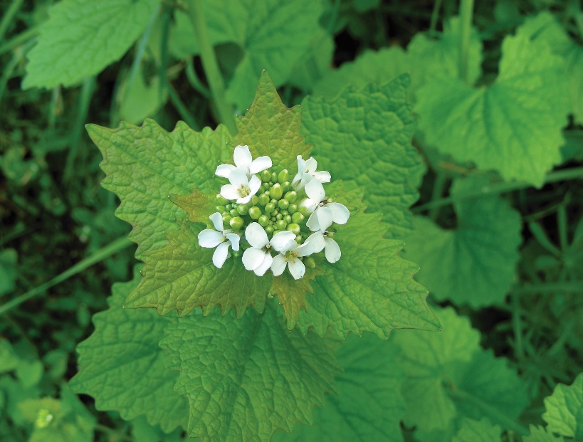First-year garlic mustard rosettes have kidney-shaped, irregularly-toothed leaves (see photo at right).
* Second-year growth can reach up to 4 feet tall and have distinctive, triangular leaves.
* Flowers begin forming during the second year of growth and consist of terminal clusters of small white blossoms with 4 petals each.

### Seed pods begin forming in May through June. Pods are up to 4 inches long and very narrow. By late June they begin turning brown and pop open to release the seeds.

### **Impacts**

* Garlic mustard is allelopathic, meaning it leaches chemicals into the soil that prevent or retard the growth of other plant species.
* Due to its allelopathy, garlic mustard can easily form a monoculture and crowd out native species.

### **Habitat & Distribution**

* Garlic mustard thrives in damp, forested areas, but it appears to grow in many conditions.
* It often takes root in disturbed soils, but can quickly spread beyond the disturbance.
* \\Scfs1\data\Weed\CWMA\CGCWMA\Farm Bill\FY16 Suggestion\EDRR Book\InDesign\2017 EDRR book_2nd edition\Linked Graphics\alpe_pods_tf.tifGarlic mustard is still limited in our area, but introduction from nearby infestations is a big threat to local ecosystems.
* Garlic mustard is considered an EDRR (early detection, rapid response) species and agencies are actively controlling it. New infestations should be reported to your local weed authority.

### **Reproduction & Spread**

* 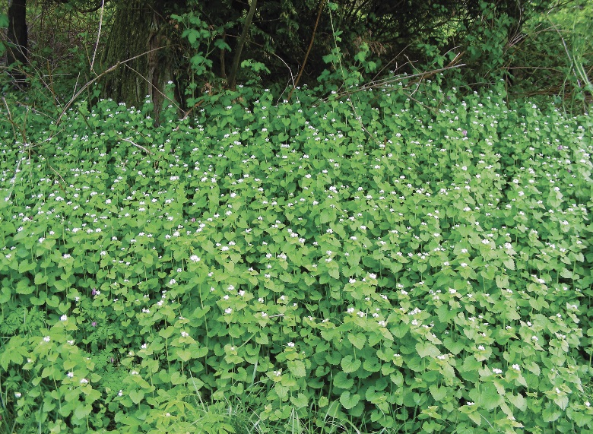Garlic mustard reproduces by seed and one plant can produce up to 1,000 seeds. Seeds form in May and June and begin spreading by late June. They can remain viable for up to 10 years.
* Once a plant has gone to seed, it will die that same season.
* Seeds are spread primarily by human activity, soil disturbance, and animals. Often new growth can be seen spreading along game trails and foot paths.
* Garlic mustard can self-pollinate.

# **CONTROL INFORMATION**

### **Integrated Pest Management**

* The preferred approach for weed control is Integrated Pest Management (IPM). IPM involves selecting from a range of possible control methods to match the management requirements of each specific site. The goal is to maximize effective control and to minimize negative environmental, economic, and recreational impacts.
* Use a multifaceted and adaptive approach. Select control methods reflecting the available time, funding, and labor of the participants, the land use goals, and the values of the community and landowners. Management will require dedication for a number of years and should allow flexibility in methods.

**Planning Considerations**

* Survey the area for weeds, set priorities, and select the best control method(s) for the site.
* Control practices should be selected to minimize soil disturbance. Minimizing disturbance prevents further infestation of weeds.
* Begin work on the perimeter of the infested areas first and move inward toward the core of the infestation.
* Monitor the site and continue to treat plants that germinate from the seed bank.
* Revegetate treatment areas to improve ecosystem function and prevent new infestations.

### **Early Detection and Prevention**

* Minimize soil disturbance from vehicles, machinery, and over-grazing to reduce areas where weeds may become established.
* Garlic mustard is relatively easy to identify year-round; however, there are a few look-alike plants (such as money plant and fringecup). Conduct a site survey to determine existing species and treatment needs.
* Garlic mustard can be manually pulled or dug. If seed pods have begun to form, plants must be bagged and disposed of in the municipal waste. Do not compost!
* Monitor for new plants and re-treat as necessary. Prevent existing plants from producing and releasing seed.
* Prevent the spread of invasive plants by thoroughly cleaning tools, boots, and vehicles (especially mowers) after working in or traveling through an infested area.

### **Manual, Mechanical, & Cultural Control**

* Garlic mustard can be pulled by hand as long as the soil is moist and the seeds aren’t popping. Take care to remove the entire root system; plants can regrow from root fragments left in the soil.
* **Mowing is not an effective method for controlling garlic mustard** as plants are capable of re-growing multiple times in a season. It can also spread easily by mowing if seeds are present.
* If the infestation is small, mulch with wood chips to control the spread of garlic mustard. Be sure to use a solid layer at least 3 inches deep for best results.

**Disposal**

* **Warning**: Garlic mustard plants will complete flowering and set seed even after being pulled. **Do not leave pulled plants on the ground or place them in compost!**
* Properly discard of all plant pieces in thick plastic bags and transport them to a sanitary landfill site.
* Never dump yard debris in natural areas.

### **Herbicide Control**

* Only apply herbicides at proper rates and for the site conditions or land usage specified on the label. **Follow all label directions** and wear recommended personal protective equipment (PPE).
* Some herbicides are toxic to fish and other aquatic invertebrates and/or may easily injure non-target species like crops growing nearby because of volatilization. **Always read and follow the label to avoid environmental and unintended damages.**
* Monitor treated areas for missed or newly germinated plants.
* Selective herbicides are preferred over non-selective herbicides when applying in a grassy area.
* **Minimize impacts to bees and other pollinators by controlling weeds before they flower. If possible, make herbicide applications in the morning or evening when bees are least active. Avoid spraying pollinators directly.**

### **Specific Herbicide Information**

Herbicides are described here by the active ingredient. Many commercial formulations are available containing specific active ingredients. **References to product names are for example only.** Directions for use may vary between brands. Read and follow the label.

Herbicide treatment of garlic mustard should occur when plants are bolting or are in early flower stage (typically early April through May), or of autumn rosettes. Garlic mustard is easiest to identify in flower stage, so control may be most effective at this time since fewer plants are missed. Herbicide applications in the spring should always be followed by monitoring and hand pulling to remove plants that may have been missed by spray. Bag and dispose of these plants properly.

* Glyphosate (e.g. RoundUp) will effectively control garlic mustard prior to seed pod formation.
* Triclopyr (Vastlan, Ortho Weed B Gon) is an effective selective control for garlic mustard when applied in early spring or to fall rosettes.
* If siliques (seed pods) are present, use triclopyr amine to ensure the plant is killed before the seeds ripen. The entire plant, including siliques, should be sprayed.
* Products containing 2,4‐D\*amine are also effective.
* \***Please use care when using herbicides that may volatize to form a vapor that can drift during weather inversions or when the temperatures are above 80°F. These herbicides (*e.g.* 2,4-D, dicamba, etc.) may damage desirable nearby non-target plants or crops following an application. For more information, and to minimize risk, always read and follow the label.**

**If you think you may have garlic mustard, please contact your local county noxious weed authority.**

This BMP does not constitute a formal recommendation. **When using herbicides, always consult the label.** Please refer to the [Pacific Northwest Weed Management Handbook](http://pnwhandbooks.org/weed/other-items/control-problem-weeds) or contact your [local](http://www.nwcb.wa.gov/nwcb_county.htm) weed authority.

**Resources**

<http://columbiagorgecwma.org/weed-listing/best-management-practices/garlic-mustard/>

<https://emswcd.org/removing-garlic-mustard/>

<http://na.fs.fed.us/spfo/invasiveplants/factsheets/pdf/garlic-mustard.pdf>

<http://www.dnr.state.mn.us/invasives/terrestrialplants/herbaceous/garlicmustard.html>

<http://www.kingcounty.gov/environment/animals-and-plants/noxious-weeds/weed-control-practices/bmp.aspx>

<http://www.nwcb.wa.gov>