## 

## **Canada Thistle**

Cirsium arvense

Sunflower Family

### **\\Scfs1\data\Weed\Photos\Canada thistle\5451400-Leslie J. Mehroff_Univ of Conn_Bugwood.org.jpgINTRODUCTION**

### **Identification Tips**

* Canada thistle is a rhizomatous, perennial, herbaceous plant growing 2-5 feet in height, with slender, grooved stems branching at the top.
* Lateral roots (or rhizomes) grow 3 or more feet deep and spread vigorously.
* 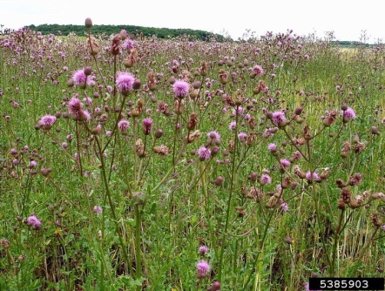Purple to pink flower heads cluster at the tips of the branched stems from June to October. Flower heads are ½ to ¾ inch in diameter.
* Plants begin as a rosette and then shoot upright after 2-4 weeks. Stems can be slightly hairy or without hairs.
* The leaves are alternate and oblong with irregularly lobed margins and crinkled edges terminating in spines. Leaf surfaces can be densely hairy to glabrous (no hairs present), with hairs on leaf undersides.
* The seeds are small, light brown, smooth and slightly tapered, with a tuft of tan hair loosely attached to the tip. They are dispersed by wind.

### **Impacts**

* Canada thistle is common in overgrazed pastures where it may form dense stands. It’s not palatable to livestock and reduces forage potential.
* It is a common weed of roadsides, pastures, burned areas, and forest clear cuts where it can dominate and reduce the growth of tree seedlings.

### **Habitat & Distribution**

* Canada thistle is common in disturbed and overgrazed areas and becomes a dominant species following disturbance.
* It sometimes occurs in wet areas where water levels fluctuate. It can invade riparian areas from adjacent disturbed areas.

### **Reproduction & Spread**

* 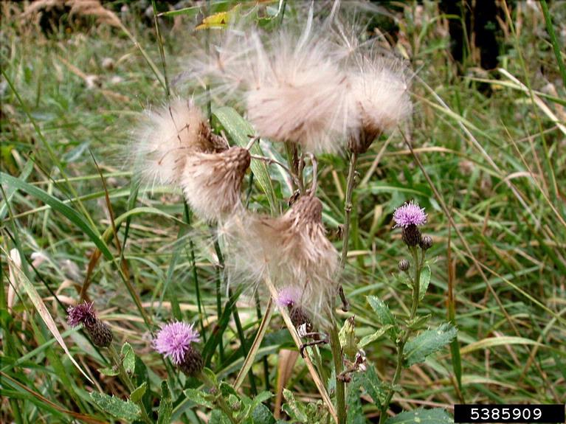Canada thistle reproduces by both seeds and rhizomes.
* Emergence occurs in early May, with the plants bolting in mid- to late-June.
* Plants produce 1,000 seeds on average and may produce up to 5,300 seeds. Seeds are dispersed by the wind.
* Seeds usually germinate in the spring and fall, but tilling, grazing, and other soil disturbances may cause them to germinate at other times.
* The seeds remain viable in the soil for over 20 years.

# **CONTROL INFORMATION**

### **Integrated Pest Management**

* The preferred approach for weed control is Integrated Pest Management (IPM). IPM involves selecting from a range of possible control methods to match the management requirements of each specific site. The goal is to maximize effective control and to minimize negative environmental, economic, and recreational impacts.
* Use a multifaceted and adaptive approach. Select control methods reflecting the available time, funding, and labor of the participants, the land use goals, and the values of the community and landowners. Management will require dedication for a number of years and should allow flexibility in methods.

**Planning Considerations**

* Survey the area for weeds, set priorities, and select the best control method(s) for the site.
* Control practices should be selected to minimize soil disturbance. Minimizing disturbance prevents further infestation of weeds.
* Begin work on the perimeter of the infested area first and move inward toward the core of the infestation.
* Monitor the site and continue to treat plants that germinate from the seed bank.
* Re-vegetate areas where weeds have been removed to improve ecosystem function and prevent new infestations.

### **Early Detection and Prevention**

* The best method of controlling Canada thistle is to prevent its establishment by destroying plants before they go to seed. Survey often for new plants.
* Minimize soil disturbance from vehicles, machinery, and overgrazing to reduce seed germination.
* If there are more rosettes than can be treated manually, treat with an appropriate herbicide in the spring or fall.
* Monitor for new plants and re-treat as necessary. Ensure any existing plants do not produce and release seed.
* Cut and bag seed heads from plants to prevent seed spread. Seeds should be disposed of in the municipal waste, *never in the compost!*
* Prevent the spread of Canada thistle by thoroughly cleaning tools, boots, and vehicles after working in or traveling through an infested area.

### **Manual, Mechanical, & Cultural Control**

* Repeated and frequent pulling or hand-cutting of individual plants may eventually reduce small infestations, but typically hand pulling or digging promotes the growth of rhizomatous plants and is not advised for larger infestations.
* Plants in flower can form viable seeds even after removal, so carefully bag and dispose of all flower heads in the municipal waste.
* Mow plants to prevent seed production prior to flowering. Avoid mowing plants in full flower, as cut flowers may still form viable seeds. Mow repeatedly throughout the season to prevent re-flowering.
* Inhibit thistle growth by planting species that will overshadow the weeds. Canada thistle is not shade tolerant.
* Prescribed fire may be effective in controlling this species. Late spring burns, between May and June, have the biggest impact on this plant. During the first three years of control efforts, burns should be conducted annually.

### **Biological Control**

Biological control is the deliberate introduction of insects, mammals, or other organisms which adversely affect the target weed species. Biological control is most effective when used in conjunction with other control techniques.

* *Urophora cardui,* a stem gall fly, is the only Canada thistle biocontrol insect approved for use in both Washington and Oregon. Females lay eggs on developing shoots, while larvae burrow into shoots. Their feeding triggers the formation of galls (abnormal swellings) that stress the plant. Growth and flowering may be reduced, but this agent alone does not kill plants or prevent spread.
* *Rhinocyllus conicus,* a seed head weevil and *Ceutorhynchus litura,* a crown/root weevil are agents approved for use in Oregon.
* Mowing is not recommended in conjunction with biocontrols.

### **Herbicide Control**

* Only apply herbicides at proper rates and for the site conditions or land usage specified on the label. **Follow all label directions** and wear recommended personal protective equipment (PPE).
* Some herbicides are toxic to fish and other aquatic invertebrates and/or may easily injure non-target species like crops growing nearby because of volatilization. **Always read and follow the label to avoid environmental and unintended damages.**
* For control of large infestations, herbicide use may be effective, either alone or in combination with mowing. Treated areas should not be mowed until after the herbicide has taken effect and weeds are brown and dead.
* Monitor treated areas for missed and newly germinated plants.
* Selective herbicides are preferred over non-selective herbicides when applying in a grassy area.
* **Minimize impacts to bees and other native pollinators by controlling weeds before they flower. If possible, make herbicide applications in the morning or evening when bees are least active. Avoid spraying pollinators directly.**

### **Specific Herbicide Information**

Herbicides are described here by the active ingredient. Many commercial formulations are available containing specific active ingredients. **References to product names are for example only.** Directions for use may vary between brands.

* A foliar spot application of glyphosate (Roundup) applied in the spring when plants are 6-10 inches tall is an effective treatment. (Note: glyphosate is non-selective and should not be used where grass is desired.)
* Products containing triclopyr, 2,4-D amine, dicamba, a combination of 2,4-D and dicamba (e.g. Weedmaster), clopyralid, or aminopyralid (Milestone) are effective when applied during the growing season.\*
* \***Please use care when using herbicides that may volatize to form a vapor that can drift during weather inversions or when the temperatures are above 80°F. These herbicides (*e.g.* 2,4-D, dicamba, etc.) may damage desirable nearby non-target plants or crops following an application. For more information, and to minimize risk, always read and follow the label.**
* Cutting at bloom (usually near summer solstice) and applying Milestone or clopyralid to the regrowth late summer or early fall is very effective.
* Annual treatments for 2-3 years will be necessary.

This BMP does not constitute a formal recommendation. **When using herbicides, always consult the label.** Please refer to the [Pacific Northwest Weed Management Handbook](http://pnwhandbooks.org/weed/other-items/control-problem-weeds) or contact your [local](http://www.nwcb.wa.gov/nwcb_county.htm) weed authority.

**Resources**

<http://columbiagorgecwma.org/weed-listing/best-management-practices/canada-thistle/>

<http://www.co.jefferson.wa.us/WeedBoard/pdfs/FactSheets/CanadaThistle.pdf>

<http://hortsense.cahnrs.wsu.edu/Home/HortsenseHome.aspx>

<http://www.ipm.ucdavis.edu>

<http://mdc.mo.gov/your-property/problem-plants-and-animals/invasive-plants/canada-thistle-control>

<http://www.oregon.gov/ODA/programs/Weeds/Pages/BiologicalControl.aspx>

<http://www.nwcb.wa.gov>