## 

## **Cutleaf/Himalayan blackberry**

Rubus laciniatus/R. bifrons

Rose Family

### **\\Scfs1\data\Weed\Photos\Blackberry\R. armeniacus\5447327_arm_Leslie J Merhoff_Univ of Conn_Bugwood.org.jpgINTRODUCTION**

### **Identification Tips**

### Both Himalayan and cutleaf blackberry are robust, sprawling perennial vines with stems having large, stiff thorns.

* Canes can grow up to 10 feet tall with trailing canes reaching up to 40 feet in length. Young canes arch as they grow longer, eventually reaching the ground and rooting at the nodes.
* Both invasive blackberry species grow in full sun, forming dense, thorny thickets. They are often found intermingled.

*R. bifrons*

* 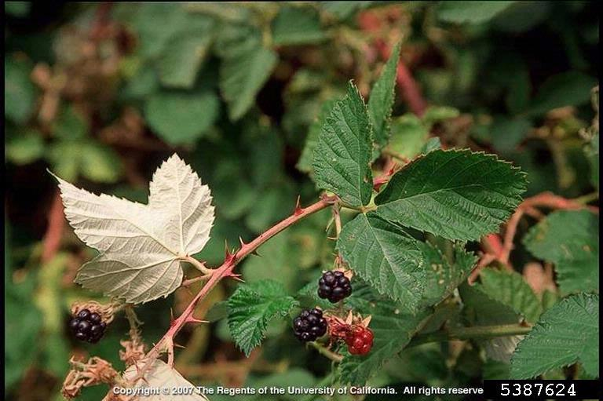The compound leaves of Himalayan blackberry are large, round to oblong, and toothed. The leaves typically come in sets of three (on trailing canes) or five (on main stems). The palmately compound leaves of cutleaf blackberry have 3 to 5 deeply lacerated leaflets.
* The flowers of both plants are pink to white, about one inch in diameter, and borne in clusters of 5 to 20.
* The native trailing blackberry (*Rubus ursinus*) is low-growing and less robust than the two introduced species. The stems are thinner and the leaves are composed of three leaflets.

*R. bifrons*

### \\Scfs1\data\Weed\Photos\Blackberry\R. laciniatus\5446235_laciniatus_Leslie J Mehrhoff_Univ of Conn_Bugwood.org.jpg**Impacts**

* Cutleaf and Himalayan blackberry are highly invasive and difficult to control.
* They out-compete native understory vegetation and prevent the establishment of desirable native shade-intolerant trees such as Douglas-fir.
* Blackberry can limit the movement of large animals by forming large, impenetrable thickets.

*R. laciniatus*

### **Habitat & Distribution**

* **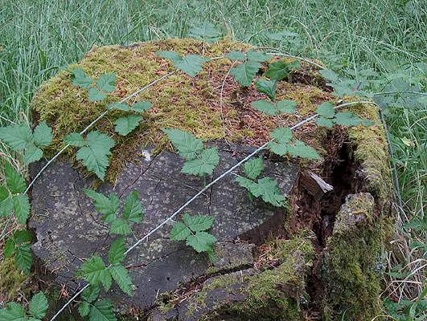**Non-native blackberries have become a significant problem on the west side of the Cascades where they are much more aggressive than on the east side.
* They can be found in a myriad of habitats such as roadsides, vacant lands, pastures, forest plantations, creek gullies, river flats, riparian areas, fence lines, and right-of-way corridors.

*R. ursinus (native)*

### **Reproduction & Spread**

* Invasive blackberry reproduces vegetatively by root and by seeds which are dispersed by birds and other animals eating the fruit.
* The plants begin flowering in spring with fruit ripening in midsummer to early August.
* Daughter plants can form where canes touch the ground and begin rooting.
* Seeds can remain viable in the soil for several years.

# **CONTROL INFORMATION**

### **Integrated Pest Management**

* The preferred approach for weed control is Integrated Pest Management (IPM). IPM involves selecting from a range of possible control methods to match the management requirements of each specific site. The goal is to maximize effective control and to minimize negative environmental, economic, and recreational impacts.
* Use a multifaceted and adaptive approach. Select control methods reflecting the available time, funding, and labor of the participants, the land use goals, and the values of the community and landowners. Management will require dedication for a number of years and should allow flexibility in methods.

**Planning Considerations**

* Survey area for weeds, set priorities, and select the best control method(s) for the site.
* Control practices should be selected to minimize soil disturbance. Minimizing disturbance prevents further infestations of weeds.
* Begin work on the perimeter of the infested area first and move inward toward the core of the infestation.
* Monitor the site and continue to treat plants that germinate from the seed bank.
* Revegetate the treatment areas to improve ecosystem function and prevent new infestations.

### **Early Detection and Prevention**

* Blackberry is easily identifiable throughout the year.
* Control new infestations as early as possible.
* Minimize soil disturbance from vehicles, machinery, and over-grazing to reduce seed germination.
* Monitor for new plants and re-treat as necessary. Ensure any existing plants do not produce and release seed.
* Prevent the additional spread of blackberry by thoroughly cleaning tools, boots, and vehicles after working in or traveling through an infested area.

### **Manual, Mechanical, & Cultural Control**

* When plants are young, hand pull the stem close to the ground and uproot the root ball. This method is most effective in loose soils or after a rain.
* For small infestations, dig up root crowns and grub roots. Be sure to monitor the work area for large root fragments which, when left in the ground, can re-sprout.
* Mowing, including the use of riding mowers and tractor-mounted mowers, can be very effective to control blackberries but may also harm desirable plants. Cut vines several times a year over several years to exhaust the energy reserves. Do not mow where soils are highly susceptible to compaction or erosion, or where soils are very wet.
* **Note:** Birds may nest in blackberry patches from early spring through July. Mow large berry thickets during dry periods in the fall or winter to prevent damage to nesting birds. Once the large canes have been cut, follow up by mowing the younger plants in the summer.
* Plant trees to control blackberry over the long run. Established trees will shade out blackberry and improve habitat for other native species and wildlife.

### **Biological Control**

Biological control is the deliberate introduction of insects, mammals, or other organisms which adversely affect the target weed species. Biological control is generally most effective when used in conjunction with other control techniques.

* Goats or pigs may be effective in controlling blackberry re-growth during the first four years. On mature stands, goats tend to only strip the leaves off the canes. Like mowing, grazing must be continuous, or regrowth will occur. Care should be taken to fence off or protect any native or desirable vegetation.

### **Herbicide Control**

* Only apply herbicides at proper rates and for the site conditions or land usage specified on the label. **Follow all label directions** and wear recommended personal protective equipment (PPE).
* Some herbicides are toxic to fish and other aquatic invertebrates and/or may easily injure non-target species like crops growing nearby because of volatilization. **Always read and follow the label to avoid environmental and unintended damages.**
* For control of large infestations, herbicide use may be effective either alone or in combination with mowing. Treated areas should not be mowed until after the herbicide has taken effect and weeds are brown and dead.
* Monitor treated areas for missed and newly germinated plants. Selective herbicides are preferred over non-selective herbicides when applying in a grassy area.
* **Minimize impacts to bees and other pollinators by controlling weeds before they flower. If possible, make herbicide applications in the morning or evening when bees are least active. Avoid spraying pollinators directly.**

### **Specific Herbicide Information**

Herbicides are described here by the active ingredient. Many commercial formulations are available containing specific active ingredients***.* References to product names are for example only.** Directions for use may vary between brands.

Treatment of blackberry is most effective in the late summer after fruiting and until the first frost. Control blackberry effectively with broadcast applications of a variety of herbicides including:

* Triclopyr (i.e. Vastlan, Garlon3A, Element 3A, Ortho Max Poison Ivy, and Tough Brush Killer)
* Glyphosate + triclopyr (i.e. Roundup Wild Blackberry Plus Vine Killer)
* 2,4-D combined with triclopyr (i.e. Crossbow)\*
* Glyphosate (Round-Up)
* For large infestations, a combination of mowing and then treating the regrowth may be the best option. Follow-up as necessary.
* Continuously monitor for new plants, especially following any disturbance to the soil such as tilling or construction. Birds can spread blackberry, so vigilance is required to prevent new infestations.
* **\*Please use care when using herbicides that may volatize to form a vapor that can drift during weather inversions or when the temperatures are above 80°F. These herbicides (*e.g.* 2,4-D, dicamba, etc.) may damage desirable nearby non-target plants or crops following an application. For more information, and to minimize risk, always read and follow the label.**

This BMP does not constitute a formal recommendation. **When using herbicides, always consult the label.** Please refer to the [Pacific Northwest Weed Management Handbook](http://pnwhandbooks.org/weed/other-items/control-problem-weeds) or contact your [local](http://www.nwcb.wa.gov/nwcb_county.htm) weed authority.

**Resources**

<http://columbiagorgecwma.org/weed-listing/best-management-practices/blackberry/>

<http://hortsense.cahnrs.wsu.edu/Home/HortsenseHome.aspx>

<http://pnwhandbooks.org/weed/>

<http://www.co.jefferson.wa.us/WeedBoard/pdfs/BestManagementPractices/>

<http://www.kingcounty.gov/environment/animals-and-plants/noxious-weeds/weed-control-practices/bmp.aspx>

<http://www.nwcb.wa.gov>