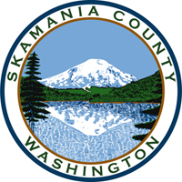
Skamania County
Noxious Weed Control Board

Special Meeting
Date: January 11, 2022

General Meeting
- Call to Order
- Approval of Agenda Items
- Approval of November Minutes

Public Comment

Financial Report
- 2022 budget

Staff Reports

Coordinator

Board Member Reports/Comments

New Business

Set meeting dates for 2022

Officer elections for 2022

Adjourn

