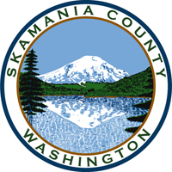
Skamania County
Noxious Weed Control Board

July Regular Meeting Agenda
Date: July 6, 2021

General Meeting
- Call to Order
- Approval of Agenda Items
- Approval of March Minutes

Public Comment

Financial Report
- Expenditure report

Staff Reports

Coordinator
- Staff/weed season update
- Enforcement
- Grants

Board Member Reports/Comments

New Business

Adjourn

