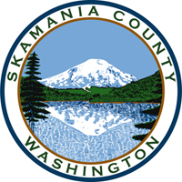
Skamania County
Noxious Weed Control Board

February Public Hearing and Regular Meeting Agenda
Date: February 2, 2021
Access: Please contact the Weed Board Office for access to the virtual public meeting, hosted on Microsoft Teams.

Public Hearing
Hear from applicants for the open board member positions.

General Meeting
- Call to Order
- Approval of Agenda Items
- Approval of January Minutes

Public Comment

Financial Report
- January expenditures

Staff Reports

Coordinator

Board Member Reports/Comments

New Business

Review applications and make recommendations to legislative authority

Officer elections for 2021

Adjourn

