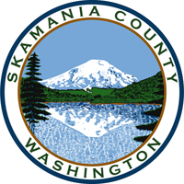
Skamania County
Noxious Weed Control Board

January Public Hearing and Regular Meeting Agenda
Date: January 5, 2021

- Call to Order
- Approval of Agenda Items
- Approval of October Minutes

Public Hearing
Review the 2021 changes to the Washington State Noxious Weed List

Public Comment

Financial Report
- 2020 budget
- 2021 budget

Staff Reports

Coordinator

Board Member Reports/Comments

New Business

Adopt the 2021 Skamania County Noxious Weed List

Set meeting dates for 2021

Officer elections for 2021

Upcoming term expirations/elections

Adjourn

