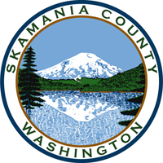
Skamania County
Noxious Weed Control Board

April Regular Meeting Agenda
Date: April 7, 2020

Due to COVID-19 closures, the April 2020 regular weed board meeting is cancelled.
The next Skamania County Noxious Weed Board meeting is scheduled for June 2, 2020 at 10 am.

