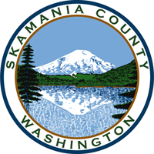
Skamania County
Noxious Weed Control Board

General Meeting
Date: August 6, 2024

General Meeting
- Call to Order
- Approval of Agenda Items
- Approval of June Minutes

Public Comment

Financial Report
- YTD
- 2025 budget

Staff Reports

Coordinator

Board Member Reports/Comments

New Business

Enforcement

Next meeting

Adjourn

