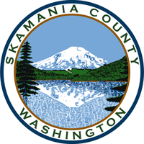
Skamania County
Noxious Weed Control Board

General Meeting
Date: April 2, 2024

General Meeting
- Call to Order
- Approval of Agenda Items
- Approval of February Minutes

Public Comment

Financial Report
- YTD

Staff Reports

Coordinator

Board Member Reports/Comments

New Business

Next meeting

Adjourn

