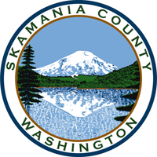
Skamania County
Noxious Weed Control Board

General Meeting and Public Hearing
Date: February 6, 2024

General Meeting
- Call to Order
- Approval of Agenda Items
- Approval of January Minutes

Public Comment

Public Hearing
- Adoption of 2024 Skamania Noxious Weed List

Financial Report
- January

Staff Reports

Coordinator

Board Member Reports/Comments

New Business

Next meeting

Adjourn

