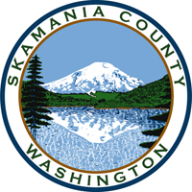
Skamania County
Noxious Weed Control Board

Special Meeting
Date: January 2, 2024

General Meeting
- Call to Order
- Approval of Agenda Items
- Approval of October Minutes

Public Comment

Financial Report
- 2023 budget
- 2024 budget

Staff Reports

Coordinator

Board Member Reports/Comments

New Business

Board member roles

Set meeting dates for 2024

Adjourn

