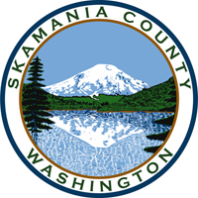
Skamania County
Noxious Weed Control Board

General Meeting
Date: August 1, 2023

General Meeting
- Call to Order
- Approval of Agenda Items
- Approval of May Minutes

Public Comment

Financial Report
- YTD
- 2024 budget

Staff Reports

Coordinator

Board Member Reports/Comments

New Business

Next meeting: October 3

Adjourn

