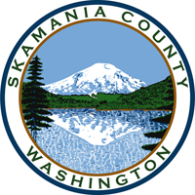
Skamania County
Noxious Weed Control Board

General Meeting
Date: May 2, 2023

General Meeting
- Call to Order
- Approval of Agenda Items
- Approval of March Minutes

Public Comment

Financial Report
- March and April

Staff Reports

Coordinator

Board Member Reports/Comments

New Business

Next meeting

Adjourn

