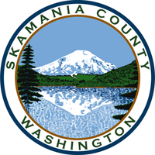
Skamania County
Noxious Weed Control Board

General Meeting and Public Hearing
Date: February 7, 2023

General Meeting
- Call to Order
- Approval of Agenda Items
- Approval of January Minutes

Public Comment

Public Hearing
- Weed Board Member Applicants
- Adoption of 2023 Skamania Noxious Weed List

Financial Report
- January

Staff Reports

Coordinator

Board Member Reports/Comments

New Business

Next meeting

Adjourn

